|  |  |
| --- | --- |
| **Ex. No. 1** | **Design a Web Page using HTML** |
| **Date of Exercise** | 18/07/2022 |
| **Web Host Link** | <https://github.com/NITHISHA73/Web_Tech_2022/upload/main> |
| **Youtube Link** | <https://youtu.be/BzmhLs3jU8Y> |

**Aim**

Create a HTML web page for your Personal Profile that conforms to HTML features and has the following elements: doctype, html, meta (in the revised html5 format), title, head, body, div, p, headings, image, anchor, table, list, html comment

**Description**

* **<head>** Defines information about the document
* **<title>** Defines the title of a document
* **<body>** The tag defines the document's body
* **<div>** Thetag defines a division or a section in an HTML document.
* **<p>** The Paragraph element. The <p> HTML element **represents a paragraph.**
* **<h>** HTML defines six levels of headings. A heading element implies all the font changes, paragraph breaks before and after, and any white space necessary to render the heading. The heading elements are H1, H2, H3, H4, H5, and H6 with H1 being the highest (or most important) level and H6 the least.
* **<img>** The tag is used to embed an image in a web page
* **<a href>** An anchor is a piece of text which marks the beginning and/or the end of a hypertext link
* **<table>** An HTML table consists of one <table> element and one or more <tr>, <th>, and <td> elements
* **<li>**

**Description List** or Definition List displays elements in definition form like in dictionary. The <dl>, <dt> and <dd> tags are used to define description list.

The 3 HTML description list tags are given below:

1. **<dl> tag** defines the description list.
2. **<dt> tag** defines data term.
3. **<dd> tag** defines data definition (description).

**Program**

<!DOCTYPE html>

<html lang="en">

<head>

    <meta charset="UTF-8">

    <meta http-equiv="X-UA-Compatible" content="IE=edge">

    <meta name="viewport" content="width=device-width, initial-scale=1.0">

    <title>Experiment-1</title>

</head>

<body>

    <div id="header">

        <center>

            <h1>RESUME</h1>

            <table cellpadding="100" >

                <tr>

                    <td>

                        <h3>

                            NITHISHA A,<br>

                            FERNHILL,<br>

                            NILGIRIS 643001,<br>

                            Ph: 8870305859,<br>

                            Email: nithishaa@karunya.edu.in

                        </h3>

                    </td>

                    <td>

                        <img src="D:\profile.jpg" alt="Profile-Pic" height="200" width="200">

                    </td>

                </tr>

            </table>

            <a href="">Visit My Website</a>

            <a href="https://karunyauniversity.in/infrastructure/campus" target="_blank">My College</a>

            <a href="mailto:nithishaa@karunya.edu.in">Email Me</a>

            <a href="">Call Me</a>

            <a href="https://www.linkedin.com/in/nithisha-a-975639209/">

                <img src="https://cdn-icons-png.flaticon.com/512/174/174857.png" alt="linkedin-icon" height="50" width="50"></a>

        </center>

    </div>

    <div id="career objective">

        <h2>Career Objective</h2>

        <p>

            Seeking an entry-level position to begin my career in a high-level professional environment.

            To secure employment with a reputable company, where I can utilize my skills and business

            studies background to the maximum. Seeking a challenging career with an MNC

       </p>

    </div>

    <div id="Academic profile">

        <h2>Academic Profile</h2>

        <center>

            <table border="1" cellpadding="10" cellspacing="0">

                <tr>

                    <th>Title</th>

                    <th>School/College</th>

                    <th>Board/University</th>

                    <th>Percentage of Marks</th>

                    <th>Year Of Passing</th>

                </tr>

                <tr>

                    <td>B.Tech</td>

                    <td>Karunya Institute of Technology and Science</td>

                    <td>Karunya University Board</td>

                    <td>9.0</td>

                    <td>2024</td>

                </tr>

                <tr>

                    <td>HSC</td>

                    <td>SRIPS SCHOOL</td>

                    <td>CBSE</td>

                    <td>85.0</td>

                    <td>2020</td>

                </tr>

                <tr>

                    <td>SSLC</td>

                    <td>BRINDISI MATRIC SCHOOL</td>

                    <td>CBSE</td>

                    <td>86.0</td>

                    <td>2018</td>

                </tr>

            </table>

        </center>

    </div>

    <div>

        <h2 id="Technical skills">Technical Skills</h2>

        <ol>

            <li >Python Programming</li>

             <li>Java Programming</li>

             <li>Html and Javascript</li>

             <li>Web Technology</li>

        </ol>

        <h2 id="adv-tc">Advanced Technical Skill</h2>

        <ul>

            <li>Iot</li>

            <li>Data Science</li>

            <li>Machine Learning</li>

            <li>Fundamentals of A.I</li>

        </ul>

    </div>

    <div id="Intership details">

        <h2>Intership Completed</h2>

        <dl>

            <dt style><b>Innovative work solutions</b></dt>

            <dd>The Internship was in the duration of 8 weeks. It was about the cloud based programming

                to store a persons information wirth advanced technologies. I completed activities and assignments

                which they gave during the class to earn my certificate.</dd>

        </dl>

    </div>

    <div id="image-gallery">

        <h2>Image Gallery</h2>

        <center><table><tr>

            <td><img src="D:\img1.jpg" alt="gallery" height="300" width="400"></td>

            <td><img src="D:\img3.jpg" alt="gallery" height="300" width="400"></td>

        </tr></table></center>

    </div>

    <br><br><br><br>

    <div class="Links">

        <center>

            <a href="#career objective">Career Objective|</a>

            <a href="#Technical skills">Technical Skills|</a>

            <a href="#Academic profile">Education|</a>

            <a href="#adv-tc">Advanced Technology Skills|</a>

            <a href="#Intership details">Interships</a>

        </center>

    </div>

    <br><br><br><br>

</body>

</html>

**Output**

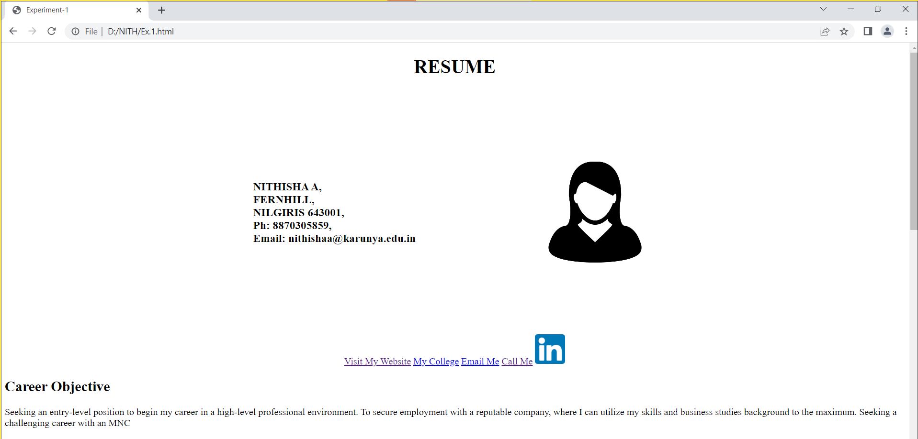

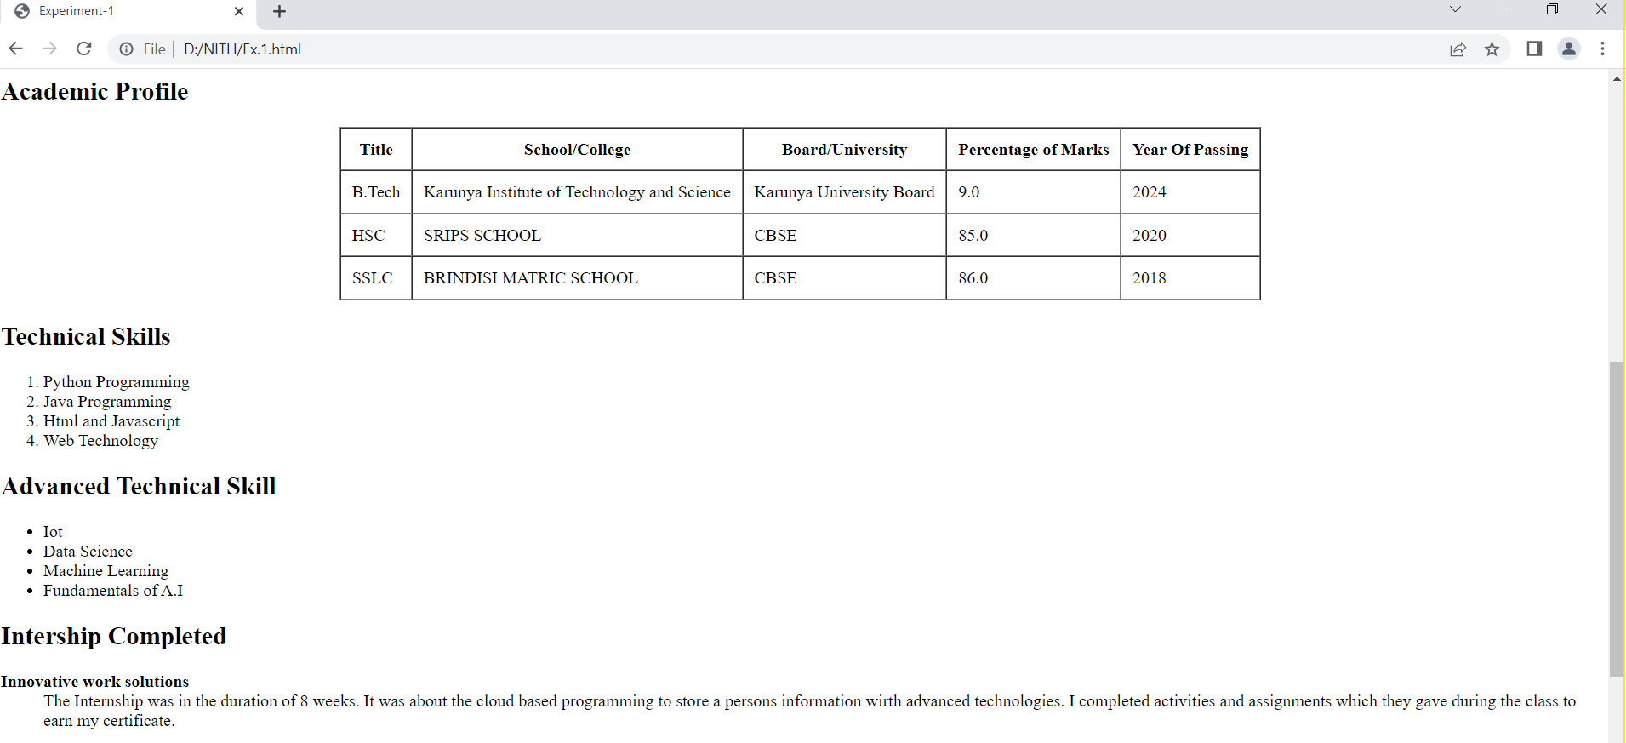

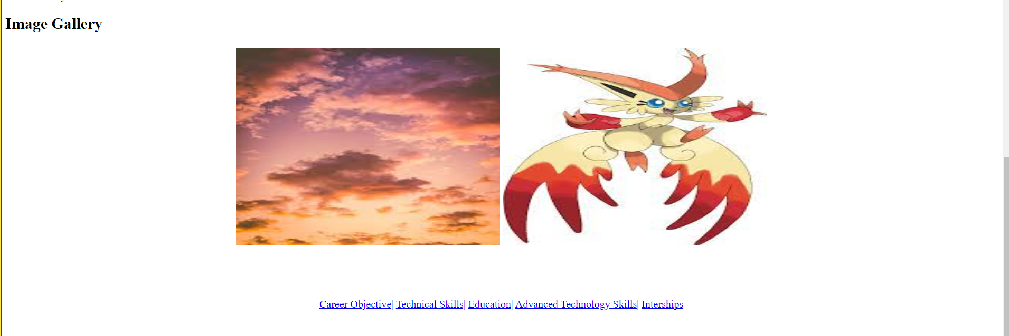

**Result**

Thus a HTML web page for Personal Profile that conforms to HTML features is coded, compiled and executed successfully.